Contents
Listikot Type 2 prefabricated health post 1
Name of the health post in-charge: Mr. Rajendra Subedi (has been working for 3 years in this health post) 1
Qualification of the health post in-charge: Health Assistant (HA) 1
Name of the VDC/ward number/District: Listikot/6/Sindhupalchowk 1
Organogram of the health post: 1
Name/Number of Auxiliary Nurse Midwifery (ANM): Ms. Prashina Poudel/ 1 2
Name/Number of Auxiliary Health Worker (AHW): not allocated by the government/2 2
Name/Number of Office Helper (OH): Mr. Chakra Bahadur Pradhan/1 2
Name of Female community health volunteers according to their wards: 2
Disease those are prevalent: 2
Delivery Care(Y/N): N 2
Average number of delivery cases per month: 0 2
Health care services: 2
Child Health 2
Family health 2
Disease Control 3
Curative Services: Basic health care services are available 3
Supporting Programs: 3
Number of available essential drugs out of 70 essential drugs allocated by the government: PCM, Cotrin, Amoxycillin, Fexofenadine, Salbutamol, Ibuprofen (insufficient), Metronidazole 4
Average number of patients per day: 15-20 4
Staff quarter (In use/Not in use): Not in use 4
Any chance of epidemics (Yes/No): No (Fever, nausea and vomiting in most of the patients) 4
Past history of epidemics (Yes/No): No 4
Marmoleum flooring (Yes/No): Yes (Lack of proper finishing) 4
Requests/Remarks/Recommendations/Comments from the Health post in-charge: 4

Listikot Type 2 prefabricated health post
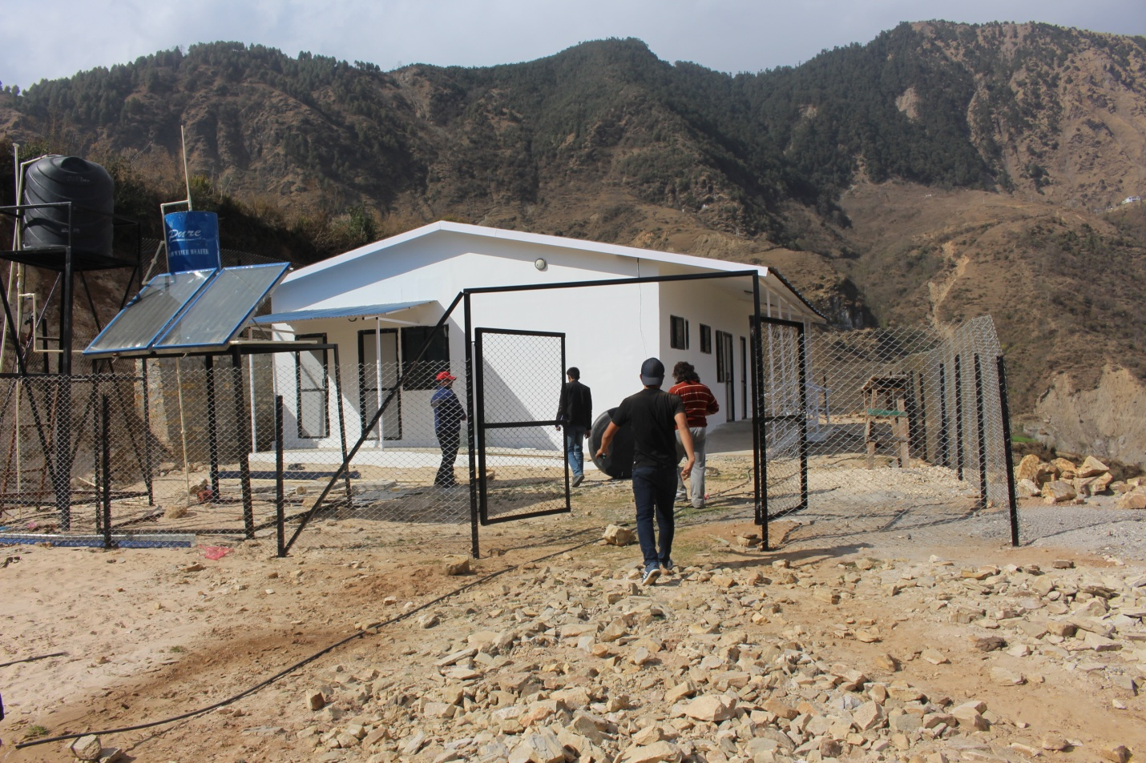

Name of the health post in-charge: Mr. Rajendra Subedi (has been working for 3 years in this health post)

Qualification of the health post in-charge: Health Assistant (HA)

Name of the VDC/ward number/District: Listikot/6/Sindhupalchowk

Organogram of the health post:
Health Assistant (HA)
OH (Office Helper)
AHW (Auxiliary Health Worker)
ANM (Auxiliary Nurse Midwifery)

Name/Number of Auxiliary Nurse Midwifery (ANM): Ms. Prashina Poudel/ 1

Name/Number of Auxiliary Health Worker (AHW): not allocated by the government/2

Name/Number of Office Helper (OH): Mr. Chakra Bahadur Pradhan/1

Name of Female community health volunteers according to their wards:
Ward Number | Name of FCHV
1. | Pembi Sherpa
2. | Nema Sagnu
3. | Nema Bati Sherpa
4. | Tara Budhathoki
5. | Geeta Pradhan
6. | Krishna Maya Pradhan
7. | Mingmar Sherpa
8. | Maili Sherpa
9. | Devi Maya Shrestha

Disease those are prevalent:
Chaitra, Baisakh: Typhoid, Diarrhea, Common Cold
Ashoj: Pneumonia, Asthma

Delivery Care(Y/N): N

Average number of delivery cases per month: 0

Health care services:

Child Health
- Immunization: BCG/DPT, Polio, Measles, PCB
- Nutrition: MUAC, Bal Vita
- Community Based-Integrated Management of Childhood Illness:
- Newborn care:

Family health
- Family Planning: As provided by Nepal government (Just received training regarding implant)
- Safe motherhood and Newborn Health: ANC,PNC (No birthing center due to the remote location and lack of awareness people still prefer home delivery)
- Female Community Health Volunteer (FCHV): 1 FCHV in each ward and 9 FCHVs in each VDC as allocated by government of Nepal; mainly responsible for health care awareness and for increasing the accessibility and efficiency of the health post at each VDC
- Demography and Reproductive Health Research: No any research conducted yet
- Adolescent Sexual and Reproductive Health Research: Awareness only on contact with health care workers

Disease Control
- Malaria: No signs, symptoms or cases
- Kala-azar: No signs, symptoms or cases
- Lymphatic Filariasis (LF): No signs, symptoms or cases
- Dengue: No signs, symptoms or cases
- Zoonoses: No signs, symptoms or cases
- Epidemiology and Outbreak management system: No any system regarding this
- Disaster Management: No any programs at present
- Tuberculosis: Some cases under treatment
- Leprosy: No signs, symptoms or cases
- HIV/AIDS and STI: No signs, symptoms or cases of HIV/AIDS and STI
- Eye care: No eye care services

Curative Services: Basic health care services are available

Supporting Programs:
- Health Training: The trainings are being conducted by government (Ministry of Health and population) and I/NGO
- Health Education, Information and Communication: Awareness programs are being provided on contact with health care service providers
- Logistic Management: The logistics are managed through I/NGO and government (District Health Office and Ministry of Health and Population)
- Public Health Laboratory Services: NA
- Administration Management: The administration is managed by health post committee under the leadership of the health post in-charge and District Health Office
- Financial Management: The Financial management is done by a VDC under the co-ordination with health post committee and District Health Office (DHO)
- Management: The management is done by the health post committee at a particular health post
- Monitoring and evaluation by the government: Monitoring or evaluation done last year by the government officials

Number of available essential drugs out of 70 essential drugs allocated by the government: PCM, Cotrin, Amoxycillin, Fexofenadine, Salbutamol, Ibuprofen (insufficient), Metronidazole

Average number of patients per day: 15-20

Staff quarter (In use/Not in use): Not in use

Any chance of epidemics (Yes/No): No (Fever, nausea and vomiting in most of the patients)

Past history of epidemics (Yes/No): No

Marmoleum flooring (Yes/No): Yes (Lack of proper finishing)

Requests/Remarks/Recommendations/Comments from the Health post in-charge:
- Request to build the retaining wall
- No any notice that this health post is being built by ANMF
- Request for paving the area outside the health post to make it more patient friendly
- Workers did not listen to the local villagers
- The workers were always in rush
- No proper finishing at the staff toilet
- Retaining wall not properly constructed
- Placenta pit not covered
- No proper finishing
- Back door not properly fitted
- No proper screwing (corrugated steel roofing not properly fixed)

Source of information: Mr. Rajendra Subedi (Health post incharge)

