Contents
Piskar Type 2 prefabricated health post 1
Name of the health post in-charge: Mr. Aman Raj Pariyar (has been working for 3 years in this health post) 1
Qualification of the health post in-charge: Health Assistant (HA) 1
Name of the VDC/ward number/District: Piskar/4/Sindhupalchowk 1
Organogram of the health post: 1
Name/Number of Auxiliary Nurse Midwifery (ANM): Ms. Neera Jeerel/1; 1 ANM still to be allocated by the government 2
Name/Number of Auxiliary Health Worker (AHW): not allocated by the government/2 2
Name/Number of Office Helper (OH): Ms. Shanta Kumari Khatri/1 2
Disease those are prevalent: Viral influenza, Diarrhea, Enteric fever 2
Delivery Care(Y/N): Y 2
Health care services: 2
Child Health 2
Family health 2
Disease Control 2
Curative Services: Basic health care services are available 3
Supporting Programs: 3
Number of available essential drugs out of 70 essential drugs allocated by the government: Scarcity of drugs (especially Metronidazole) 3
Average number of patients per day: 15-20 each day 3
Staff quarter (In use/Not in use): In use 3
Any chance of epidemics (Yes/No): No 3
Past history of epidemics (Yes/No): No 3
Marmoleum flooring (Yes/No): Yes (No proper finishing) 3
Requests/Remarks/Recommendations/Comments from the Health post in-charge: 3

Piskar Type 2 prefabricated health post
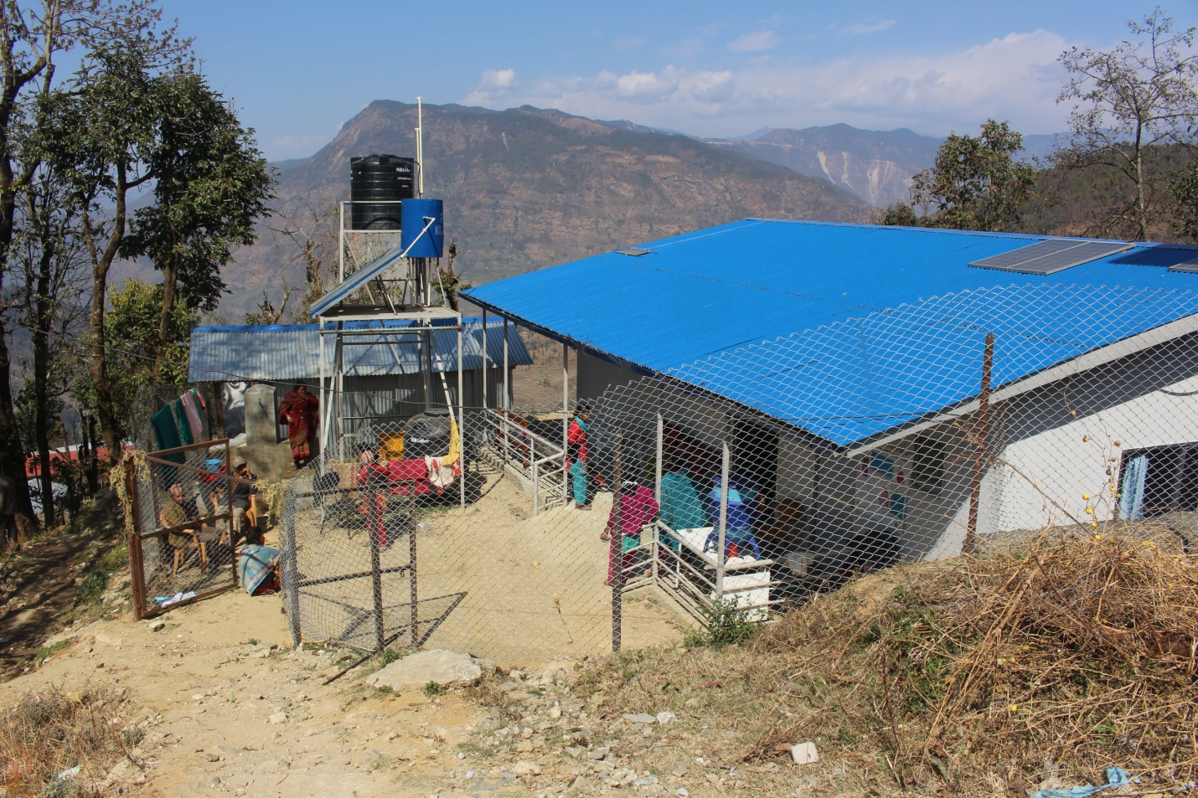

Name of the health post in-charge: Mr. Aman Raj Pariyar (has been working for 3 years in this health post)

Qualification of the health post in-charge: Health Assistant (HA)

Name of the VDC/ward number/District: Piskar/4/Sindhupalchowk

Organogram of the health post:
Health Assistant (HA)
OH (Office Helper)
AHW (Auxiliary Health Worker)
ANM (Auxiliary Nurse Midwifery)

Name/Number of Auxiliary Nurse Midwifery (ANM): Ms. Neera Jeerel/1; 1 ANM still to be allocated by the government

Name/Number of Auxiliary Health Worker (AHW): not allocated by the government/2

Name/Number of Office Helper (OH): Ms. Shanta Kumari Khatri/1

Disease those are prevalent: Viral influenza, Diarrhea, Enteric fever

Delivery Care(Y/N): Y

Health care services:

Child Health
- Immunization: All services as per the National Immunization Schedule
- Nutrition: All services as provided by the government
- Community Based-Integrated Management of Childhood Illness: All services as provided by the government
- Newborn care: All services as provided by the government

Family health
- Family Planning: All temporary methods as provided by the government
- Safe motherhood and Newborn Health: All services as provided by the government including Antenatal Care (ANC), Postnatal Care (PNC) and Birthing Center
- Female Community Health Volunteer (FCHV): 1 FCHV in each ward and 9 FCHVs in each VDC as allocated by government of Nepal; mainly responsible for health care awareness and for increasing the accessibility and efficiency of the health post at each VDC
- Demography and Reproductive Health Research: No any research conducted yet
- Adolescent Sexual and Reproductive Health Research: Awareness only on contact with health care workers

Disease Control
- Malaria: No signs, symptoms or cases
- Kala-azar: No signs, symptoms or cases
- Lymphatic Filariasis (LF): No signs, symptoms or cases
- Dengue: No signs, symptoms or cases
- Zoonoses: Rabies, tetanus
- Epidemiology and Outbreak management system: No any system regarding this
- Disaster Management: No any programs at present
- Tuberculosis: 3 cases under treatment
- Leprosy: No signs, symptoms or cases
- HIV/AIDS and STI: No signs, symptoms or cases of HIV/AIDS and 1-2 cases of STI (especially Pelvic Inflammatory Disease)
- Eye care: Basic eye care services are available

Curative Services: Basic health care services are available

Supporting Programs:
- Health Training: The trainings are being conducted by government (Ministry of Health and population) and I/NGO
- Health Education, Information and Communication: Awareness programs are being provided on contact with health care service providers
- Logistic Management: The logistics are managed through I/NGO and government (District Health Office and Ministry of Health and Population)
- Public Health Laboratory Services: NA
- Administration Management: The administration is managed by health post committee under the leadership of the health post in-charge and District Health Office
- Financial Management: The Financial management is done by a VDC under the co-ordination with health post committee and District Health Office (DHO)
- Management: The management is done by the health post committee at a particular health post
- Monitoring and evaluation by the government: Just once from District Health Office, Sindhupalchowk

Number of available essential drugs out of 70 essential drugs allocated by the government: Scarcity of drugs (especially Metronidazole)

Average number of patients per day: 15-20 each day

Staff quarter (In use/Not in use): In use

Any chance of epidemics (Yes/No): No

Past history of epidemics (Yes/No): No

Marmoleum flooring (Yes/No): Yes (No proper finishing)

Requests/Remarks/Recommendations/Comments from the Health post in-charge:
- Received donation from Poland (furniture and other maintenance resources)

Source of information: Mr. Aman Raj Pariyar (Health post incharge)

