Contents
Tauthali Type 2 prefabricated health post 1
Name of the health post in-charge: Mr. Chandra Narayan Sah (has been working for 8 years in this health post) 1
Qualification of the health post in-charge: Senior Community Medical Auxiliary (SCMA) 1
Name of the VDC/ward number/District: Tauthali/1/Sindhupalchowk 1
Organogram of the health post: 1
Name/Number of Auxiliary Nurse Midwifery (ANM): Ms. Ganga Rai/ 1-currently only one ANM allocated by government 2
Name/Number of Auxiliary Health Worker (AHW): not allocated by the government 2
Name/Number of Office Helper (OH): Dahana Bahadur Shrestha/1 2
Disease those are prevalent: Dysentery, Typhoid, and Diarrhea 2
Delivery Care(Y/N): Y 2
Health care services: 2
Child Health 2
Family health 2
Disease Control 2
Curative Services: Basic health care services are available 3
Supporting Programs: 3
Number of available essential drugs out of 70 essential drugs allocated by the government: 50-60 out of 70; lack of ibuprofen, PCM, metronidazole 3
Average number of patients per day: 10-12 each day 3
Staff quarter (In use/Not in use): In use 3
Any chance of epidemics (Yes/No): No 3
Past history of epidemics (Yes/No): Influenza (2 months ago) 3
Marmoleum flooring (Yes/No): Yes (No proper finishing) 3
Requests/Remarks/Recommendations/Comments from the Health post in-charge: 3

Tauthali Type 2 prefabricated health post
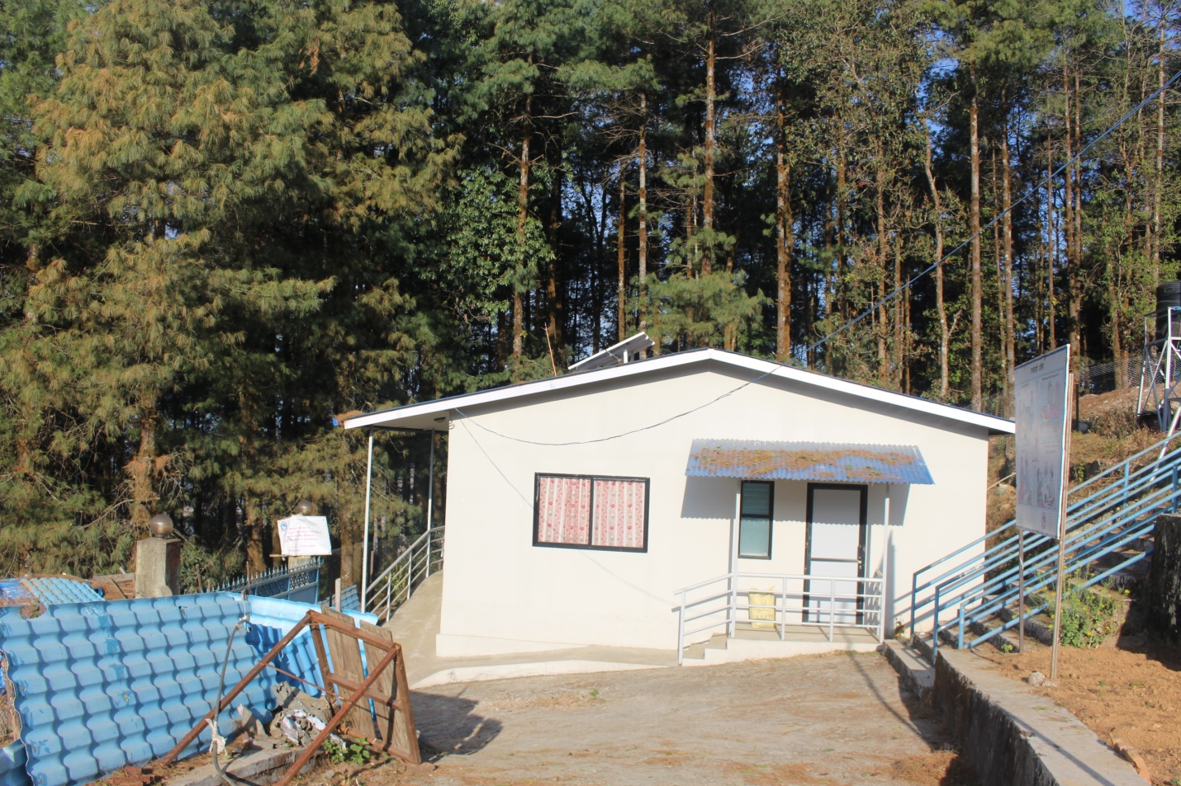

Name of the health post in-charge: Mr. Chandra Narayan Sah (has been working for 8 years in this health post)

Qualification of the health post in-charge: Senior Community Medical Auxiliary (SCMA)

Name of the VDC/ward number/District: Tauthali/1/Sindhupalchowk

Organogram of the health post:
Senior Community Medical Auxiliary (SCMA)
ANM (Auxiliary Nurse Midwifery)
AHW (Auxiliary Health Worker)
OH (Office Helper)

Name/Number of Auxiliary Nurse Midwifery (ANM): Ms. Ganga Rai/ 1-currently only one ANM allocated by government

Name/Number of Auxiliary Health Worker (AHW): not allocated by the government

Name/Number of Office Helper (OH): Dahana Bahadur Shrestha/1

Disease those are prevalent: Dysentery, Typhoid, and Diarrhea

Delivery Care(Y/N): Y

Health care services:

Child Health
- Immunization: All services as per the National Immunization Schedule
- Nutrition: All services as provided by the government
- Community Based-Integrated Management of Childhood Illness: All services as provided by the government
- Newborn care: All services as provided by the government

Family health
- Family Planning: All services as provided by the government (Implant dipo, pills, etc)
- Safe motherhood and Newborn Health: Antenatal Care (ANC), Postnatal Care (PNC), birthing centre
- Female Community Health Volunteer (FCHV): 1 FCHV in each ward and 9 FCHVs in each VDC as allocated by government of Nepal; mainly responsible for health care awareness and for increasing the accessibility and efficiency of the health post at each VDC
- Demography and Reproductive Health Research: No any research conducted yet
- Adolescent Sexual and Reproductive Health Research: Awareness only on contact with health care workers

Disease Control
- Malaria: No signs, symptoms or cases
- Kala-azar: No signs, symptoms or cases
- Lymphatic Filariasis (LF): No signs, symptoms or cases
- Dengue: No signs, symptoms or cases
- Zoonoses: Some cases present
- Epidemiology and Outbreak management system: No any system regarding this
- Disaster Management: Done programs regarding sanitation with partnership with NGO
- Tuberculosis: 2-3 cases under treatment
- Leprosy: No signs, symptoms or cases
- HIV/AIDS and STI: No signs, symptoms or cases of HIV/AIDS and 2-3 cases of STI cases
- Eye care: Basic eye care services are available

Curative Services: Basic health care services are available

Supporting Programs:
- Health Training: The trainings are being conducted by government (Ministry of Health and population) and I/NGO
- Health Education, Information and Communication: Awareness programs are being provided on contact with health care service providers
- Logistic Management: The logistics are managed through I/NGO and government (District Health Office and Ministry of Health and Population)
- Public Health Laboratory Services: NA
- Administration Management: The administration is managed by health post committee under the leadership of the health post in-charge and District Health Office
- Financial Management: The Financial management is done by a VDC under the co-ordination with health post committee and District Health Office (DHO)-Not good
- Management: The management is done by the health post committee at a particular health post
- Monitoring and evaluation by the government: No monitoring or evaluation has been done by the government till now after the construction of new prefabricated health post

Number of available essential drugs out of 70 essential drugs allocated by the government: 50-60 out of 70; lack of ibuprofen, PCM, metronidazole

Average number of patients per day: 10-12 each day

Staff quarter (In use/Not in use): In use

Any chance of epidemics (Yes/No): No

Past history of epidemics (Yes/No): Influenza (2 months ago)

Marmoleum flooring (Yes/No): Yes (No proper finishing)

Requests/Remarks/Recommendations/Comments from the Health post in-charge:
- Lack of water supply
- Request for medical and surgical supplies
- Request for furniture
- No grills on windows
- No proper walkways outside the health post
- No proper fittings
- No al-drop lock

Source of information: Mr. Chandra Narayan Sah (Health post incharge)

