Contents
Attarpur Type 2 prefabricated health post 2
Name of the health post in-charge: Mr. Shree Narayan Thakur (has been working for 16 years in this health post) 2
Qualification of the health post in-charge: Senior Auxiliary Health Worker (SAHW) 2
Name of the VDC/ward number/District: Attarpur/4/Sindhupalchowk 2
Organogram of the health post: 2
Name/Number of Auxiliary Nurse Midwifery (ANM): Ms. Sabina Sapkota/1 3
Name/Number of Auxiliary Health Worker (SAHW): Mr. Shree Narayan Thakur/1 3
Name/Number of Health Assistant (HA): Mr. Raju Prassad Chaulagain/1 3
Name/Number of Office Helper (OH): Ms. Kabita Shrestha/1 3
Disease those are prevalent: Common cold, diarrhea, viral fever, ARI 3
Delivery Care(Y/N): N 3
Average number of delivery cases per month: 0 3
Health care services: 3
Child Health 3
Family health 3
Disease Control 3
Curative Services: Basic health care services are available 4
Supporting Programs: 4
Number of available essential drugs out of 70 essential drugs allocated by the government: Lack of essential drugs 4
Average number of patients per day: 10-15 4
Staff quarter (In use/Not in use): In use 4
Any chance of epidemics (Yes/No): No 4
Past history of epidemics: No 4
Marmoleum flooring (Yes/No): Yes 4
Requests/Remarks/Recommendations/Comments from the Health post in-charge: 4

Attarpur Type 2 prefabricated health post
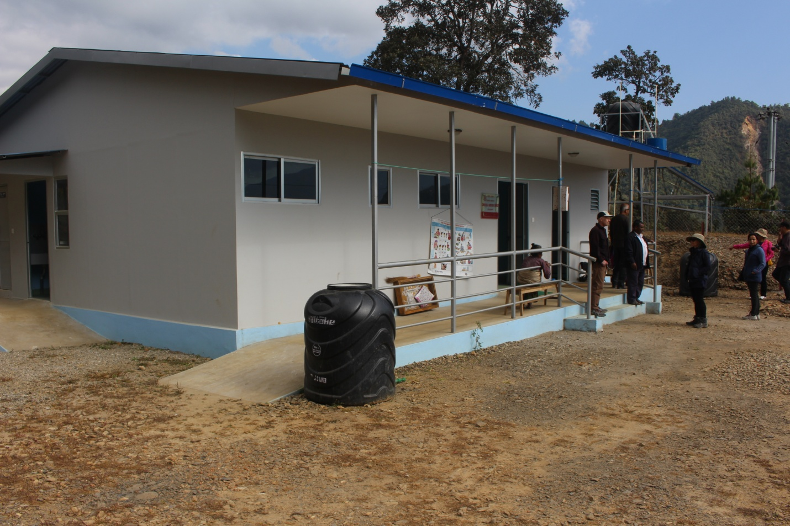

Name of the health post in-charge: Mr. Shree Narayan Thakur (has been working for 16 years in this health post)

Qualification of the health post in-charge: Senior Auxiliary Health Worker (SAHW)

Name of the VDC/ward number/District: Attarpur/4/Sindhupalchowk

Organogram of the health post:
OH (Office Helper)
AHW (Auxiliary Health Worker)
ANM (Auxiliary Nurse Midwifery)
Health Assistant (HA)

Name/Number of Auxiliary Nurse Midwifery (ANM): Ms. Sabina Sapkota/1

Name/Number of Auxiliary Health Worker (SAHW): Mr. Shree Narayan Thakur/1

Name/Number of Health Assistant (HA): Mr. Raju Prassad Chaulagain/1

Name/Number of Office Helper (OH): Ms. Kabita Shrestha/1

Disease those are prevalent: Common cold, diarrhea, viral fever, ARI

Delivery Care(Y/N): N

Average number of delivery cases per month: 0

Health care services:

Child Health
- Immunization: All services as per the National Immunization Schedule
- Nutrition: All services as provided by the government
- Community Based-Integrated Management of Childhood Illness: All services as provided by the government
- Newborn care: All services as provided by the government

Family health
- Family Planning: All services as provided by the government
- Safe motherhood and Newborn Health: All services as provided by the government
- Female Community Health Volunteer (FCHV): 1 FCHV in each ward and 9 FCHVs in each VDC as allocated by government of Nepal; mainly responsible for health care awareness and for increasing the accessibility and efficiency of the health post at each VDC
- Demography and Reproductive Health Research: NA
- Adolescent Sexual and Reproductive Health Research: Awareness only on contact with health care workers

Disease Control
- Malaria: No signs, symptoms or cases
- Kala-azar: No signs, symptoms or cases
- Lymphatic Filariasis (LF): No signs, symptoms or cases
- Dengue: No signs, symptoms or cases
- Zoonoses: No signs, symptoms or cases
- Epidemiology and Outbreak management system: NA
- Disaster Management: No any programs at present
- Tuberculosis: No signs, symptoms or cases
- Leprosy: No signs, symptoms or cases
- HIV/AIDS and STI: No signs, symptoms or cases
- Eye care: Basic eye care services are available

Curative Services: Basic health care services are available

Supporting Programs:
- Health Training: The trainings are being conducted by government (Ministry of Health and population) and I/NGO
- Health Education, Information and Communication: Awareness programs are being provided on contact with health care service providers
- Logistic Management: The logistics are managed through I/NGO and government (District Health Office and Ministry of Health and Population)
- Public Health Laboratory Services: NA
- Administration Management: The administration is managed by health post committee under the leadership of the health post in-charge and District Health Office
- Financial Management: The Financial management is done by a VDC under the co-ordination with health post committee and District Health Office (DHO)
- Management: The management is done by the health post committee at a particular health post
- Monitoring and evaluation by the government: No monitoring or evaluation has been done by the government till now after the construction of new prefabricated health post

Number of available essential drugs out of 70 essential drugs allocated by the government: Lack of essential drugs

Average number of patients per day: 10-15

Staff quarter (In use/Not in use): In use

Any chance of epidemics (Yes/No): No

Past history of epidemics: No

Marmoleum flooring (Yes/No): Yes

Requests/Remarks/Recommendations/Comments from the Health post in-charge:
- Water supply problems and solar problems
- Lack of cover in the commode at staff toilet

Source of information: Mr. Shree Narayan Thakur (Health post incharge)

