Repair, maintenance, strengthening and empowering the prefabricated health post built by ANMF

Table of Contents
Introduction 2
VDCs of Sindhupalchowk district where ANMF had helped to build prefabricated health posts 2
Details of the prefabricated health posts 3
Beneficiaries of the Health posts 4
Statement of Problem 5
o Lack of proper repair and maintenance of the Health post by the government after the handover 5
o Need of a retaining wall to preserve the prefabricated health post at Petku VDC 6
ANMF’s role in this 6
Opportunities 7
Standard list of the equipment, furniture and instruments for the health post provided and signed by government (Ministry of Health and Population) authorities: 7
Budget Allocation 8
Contact Information: 10

Introduction
The Chautara type 1 prefabricated health post and other 11 Type 2 prefabricated health posts situated at different VDCs of Sindhupalchowk district was handed over to the Government of Nepal on 28th August, 2015 and 2nd July, 2016 respectively. Amongst the 11 prefabricated health posts, Irkhu health post is also completed and is supposed to deliver its healthcare services by this month. The other health post site at Nuwakot district (Thapduipippal healthpost) is still to be constructed as there is a need of proper land allocation.
Below are some of the details regarding the health post rebuilding project:

VDCs of Sindhupalchowk district where ANMF had helped to build prefabricated health posts

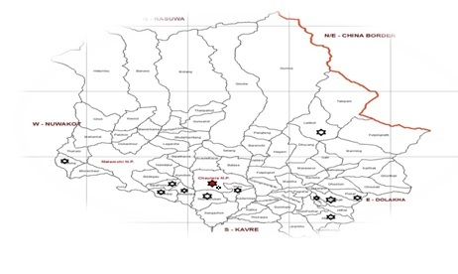

Details of the prefabricated health posts
Type of the prefabricated Health post | Description | Details
Type 1 | Materials | Foundation on brick and cement
Mortar with RCC tie beam
Prefabricated walls
Metal post and truss
CGI sheet roofing
Aluminium doors and windows
 | Catchment area | >5000 population
 | Total plinth area | 124 square meter (1,333 feet)
 | Interiors | - Working Space  - Facilities required for basic health service delivery  - Two separate rooms for staff quarter  - A solar power backup system
Type 2 | Materials | Foundation on brick and cement  Mortar with RCC tie beam  Prefabricated walls  Metal post and truss  CGI sheet roofing  Aluminium doors and windows
 | Catchment area | <5000 population
 | Total plinth area | 89.27 square meter (960 square feet)
 | Interiors | - Working space  - Facilities required for basic health care service delivery  - Two rooms for staff quarter  - A solar power backup system

Beneficiaries of the Health posts

Note: Chautara Type 1 prefabricated health post receives an average of 78 patients daily (around 28,000 patients yearly) which is serving as an Outpatient department of the district hospital itself. The inflow of patient is highest at Chautara type 1 prefabricated structure. The data is yet to be received from Haibung Type 2 prefabricated health post.
Expectations from the Government of Nepal after handing over of the health post:
    - To resume healthcare service delivery in affected districts
    - To respond to the additional healthcare needs emerging after the earthquake:
      - Psychosocial Counseling
      - Rehabilitation of the disabled
      - Long-term trauma care management
    - Replenishing damaged equipment and supplies
    - To repair the damaged structure and maintain prefabricated health posts
    - To utilize the local natural and human resources efficiently

Statement of Problem
As the Government of Nepal has limited budget and human resources allocated towards the health sector of the country, it is not being very feasible for them to look after every aspect. There are other places which require detailed focus and attention, thus causing them to neglect the health posts built by ANMF. It is not very pleasant to note that the newly built structures which holds utmost importance to the society does not have the required supplies (medical and surgical supplies) and furniture inside the health care facilities. Even though fulfilling and furnishing the health center building comes under the responsibility of the Ministy of Health and Population, due to bureaucratic delays, we have seen that required equipments and furniture are not promptly filled in. The biggest sufferer is usually the villagers, the poorest of whom have no choice but to go to these health centers. We have already seen that despite giving big respite to the people in Chautara from our ANMF rebuilt health center in the hospital premises (in Chautara District Hospital), the maintenance of the new structure has been poor. It may be due to the big volume of people served by that building but definitely if we could help maintain the facility, it would directly help the people there.

Lack of proper repair and maintenance of the Health post by the government after the handover
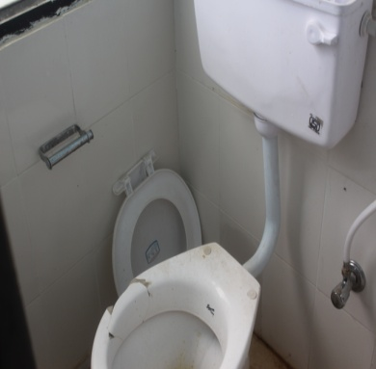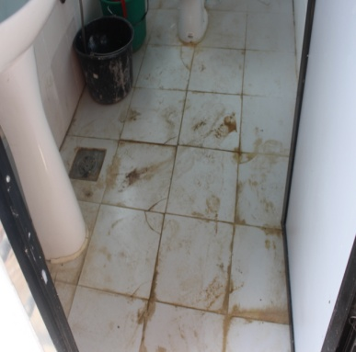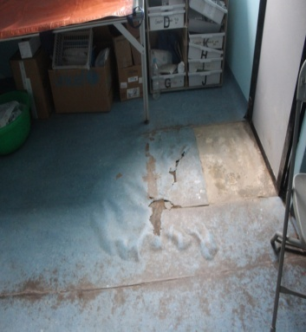
Fig: Lack of proper care and maintenance at Chautara prefabricated structure

Need of a retaining wall to preserve the prefabricated health post at Petku VDC
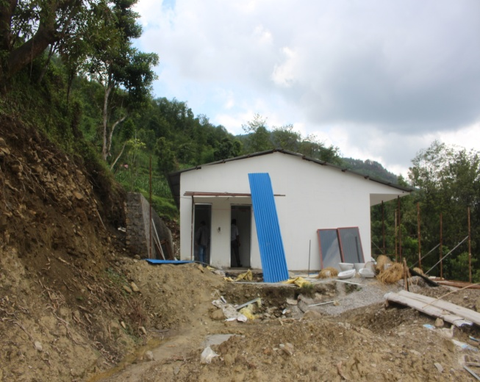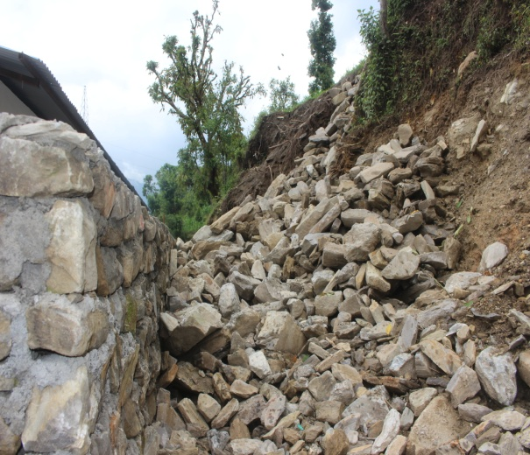
Fig: Most of the land allotted by the government are either landslide/flood prone area/hard to access which increases the cost of the construction (Retaining wall had to be constructed to protect the health post infrastructure) and no any community participation either in kind (manpower) or monetary support (for example: proper land donation by landlords of the village for the health post, local materials). Theft and robbery of construction materials were also notable threats faced during the construction period

ANMF’s role in this
- Allocate some budget to maintain and repair damaged structures (exteriors or interiors) pertaining to the prefabricated health posts built by ANMF
- Provide essential supplies (medical and surgical) as well as furniture so as to strengthen the health care delivery services
- Maintenance is of major importance as it caters to the thousands of people in the district. It is also crucial to avoid any kind of disease outbreaks.
Strengthening and empowering the existing health posts:
- To provide required medical equipments and trainings (Emergency care trainings, etc) so as to deliver quality health care services to the patients (If required)
- To raise public health awareness
- To provide proper monitoring and supervision
- To conduct new sustainable projects. For example: Telemedicine project in each of the prefabricated health posts built by ANMF
- To allocate an emergency fund for each of the prefabricated health posts in case of urgency, disaster, crisis, etc.

Opportunities
- New collaborating opportunities: Telemedicine, Outreach clinics, Health camps, Equipments and supplies, Emergency care trainings (CPR training, etc)
- Public Private Partnership
- Behavior Change Communication approach
- Community participation
- Humanitarianism

Standard list of the equipment, furniture and instruments for the health post provided and signed by government (Ministry of Health and Population) authorities:
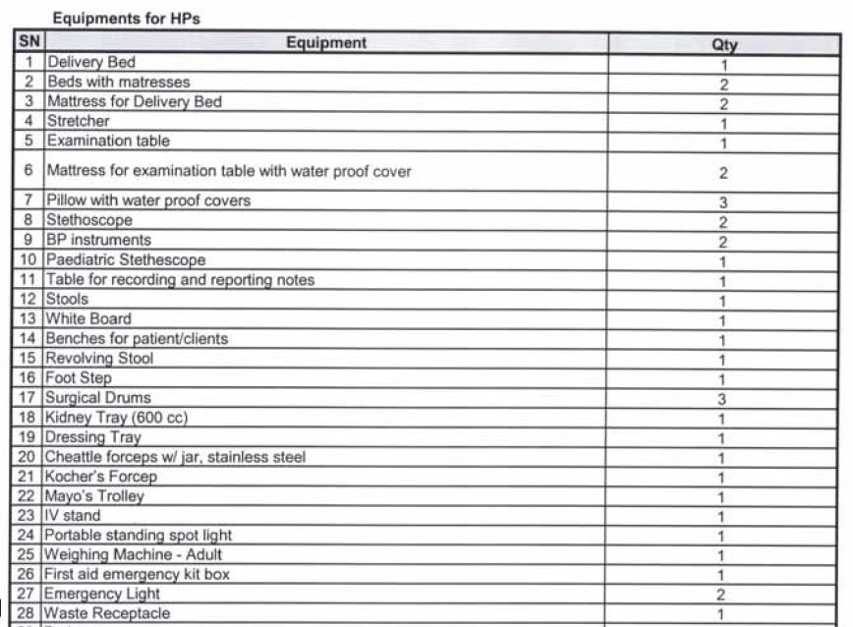
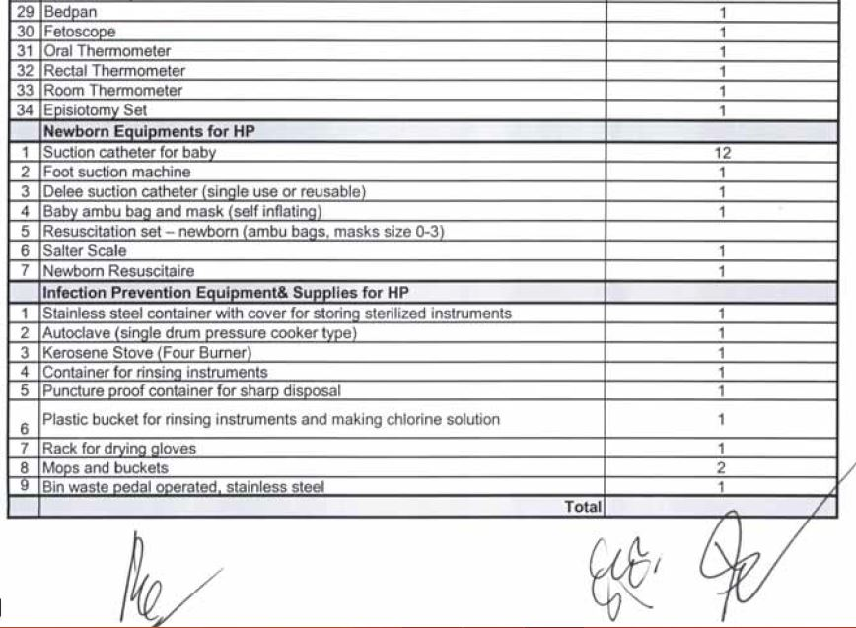
Fig: standard list of the equipment, furniture and equipments required for the health post
As the newly built prefabricated health post is not well equipped with these materials, the health care manpower is unable to deliver the health care services through the health post effectively and efficiently. In most of the health post there is a lack of newborn equipments which disables them to provide newborn and delivery services. If these newly built health posts are well equipped with these listed materials and equipments then the health care delivery services could be enriched from the grass root level.

Budget Allocation
America Nepal Medical Foundation-Nepal proposes America Nepal Medical Foundation-US to fund $10,000 at each of the prefabricated health posts so as to repair, maintain, strengthen, empower prefabricated health posts and to set aside an emergency fund for each health posts in case of urgent situations.

Name of the Health post | Construction stage/Description | Amount
Name of the Health post | Construction stage/Description | Emergency fund | Other probable required fund | Description/Requirement
- Chautara Type 1 prefabricated structure (running as OPD) | Completed ( Marmoleum flooring needs to be changed) | $5,000 | $5,000 | Need to repair the toilet and marmoleum flooring
- Thulosirubari Type 2 prefabricated health post | Completed | $5,000 | $5,000 | Lack of medical, surgical supplies and furniture
- Bhotsipa Type 2 prefabricated health post | Completed (Solar power backup was stolen and our vendor changed it without incurring any cost to ANMF and heavy rainfall partially damaged the outside structure of the health post) | $5,000 | $5,000 | Lack of medical, surgical supplies and furniture
- Sipapokhare Type 2 prefabricated health post | Completed | $5,000 | $5,000 | Lack of medical, surgical supplies and furniture as well as lack of awareness campaigns
- Bhimtar Type 2 prefabricated health post | Completed | $5,000 | $5,000 | Lack of medical, surgical supplies and furniture
- Haibung Type 2 prefabricated health post | Completed | $5,000 | $5,000 | Lack of medical, surgical supplies and furniture
- Attarpur Type 2 prefabricated health post | Completed | $5,000 | $5,000 | Need of an ambulance service and lack of medical, surgical supplies and furniture
- Petku Type 2 prefabricated health post | Completed | $5,000 | $5,000 | Need of a retaining wall and lack of medical, surgical supplies and furniture
- Piskar Type 2 prefabricated health post | Completed | $5,000 | $5,000 | Lack of medical, surgical supplies and furniture and need of an ambulance service
- Tauthali Type 2 prefabricated health post | Completed | $5,000 | $5,000 | Need of an ambulance service and lack of medical, surgical supplies and furniture
- Listikot Type 2 prefabricated health post | Completed | $5,000 | $5,000 | Severe need of an ambulance service and lack of medical, surgical supplies and furniture
- Irkhu Type 2 prefabricated health post | Completed | $5,000 | $5,000 | Need of a proper water supply system and lack of medical, surgical supplies and furniture
- (Thapduipippal type 2 prefabricated health post) Nuwakot | Not started (need to allocate a proper land) | $5,000 | $5,000
Total Amount |  | $130,000

Contact Information:
ANMF-Nepal
anmfnepalrequests@gmail.com

