SCOPIA DESKTOP CLIENT INSTALLATION GUIDELINES

Avaya SCOPIA Desktop Client provides full functionality and features to communicate via soft clients (Laptops and Smartphones).
Procedure to install and operate SCOPIA Desktop Client are as follows:

STEP 1:
On Windows, go to start menu or press the windows button on your keyboard
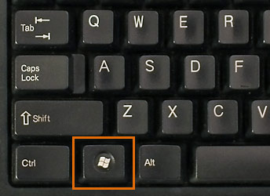

STEP2: Search for internet explorer by typing “Internet Explorer” as shown in the image below
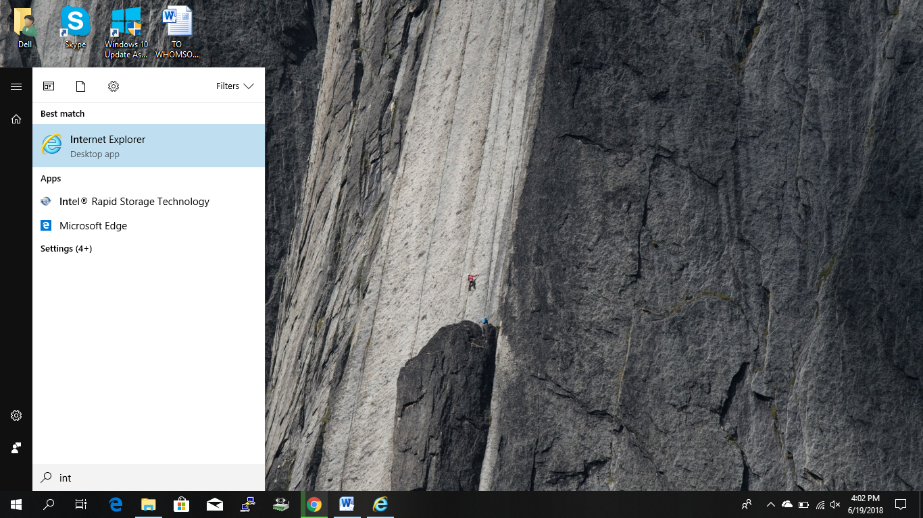
STEP3: Open “Internet Explorer” by pressing ENTER button or simply by clicking the “Internet Explorer” icon displayed in the search menu.

STEP4: After Internet Explorer opens, type the Scopia Server address (incase of BIR HOSPPITAL type 202.70.82.185) on the address bar and press the enter button as shown in the image below

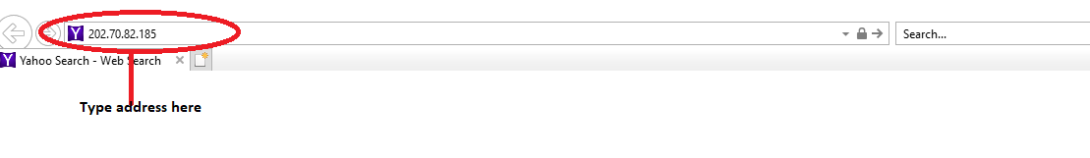

STEP4: After searching for the particular Scopia Server’s address a new window opens up asking for your name to be displayed throughout the video conferencing session as shown in the image below:

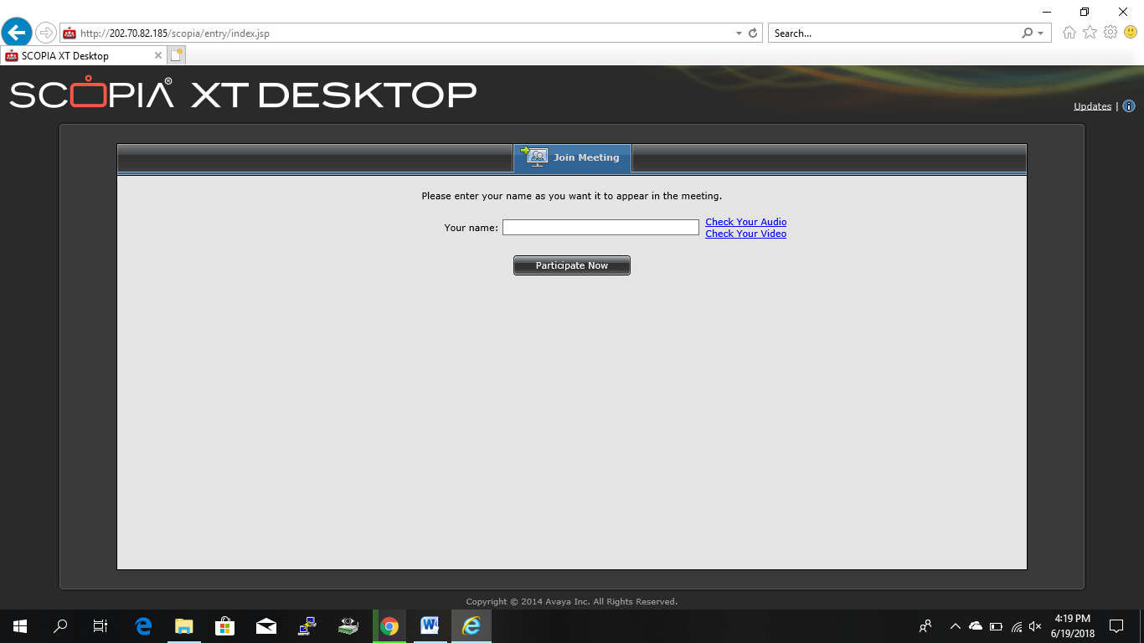

STEP5: After entering the name click on the “Participate Now” button which directs you to the meeting room automatic initial setup as shown below:
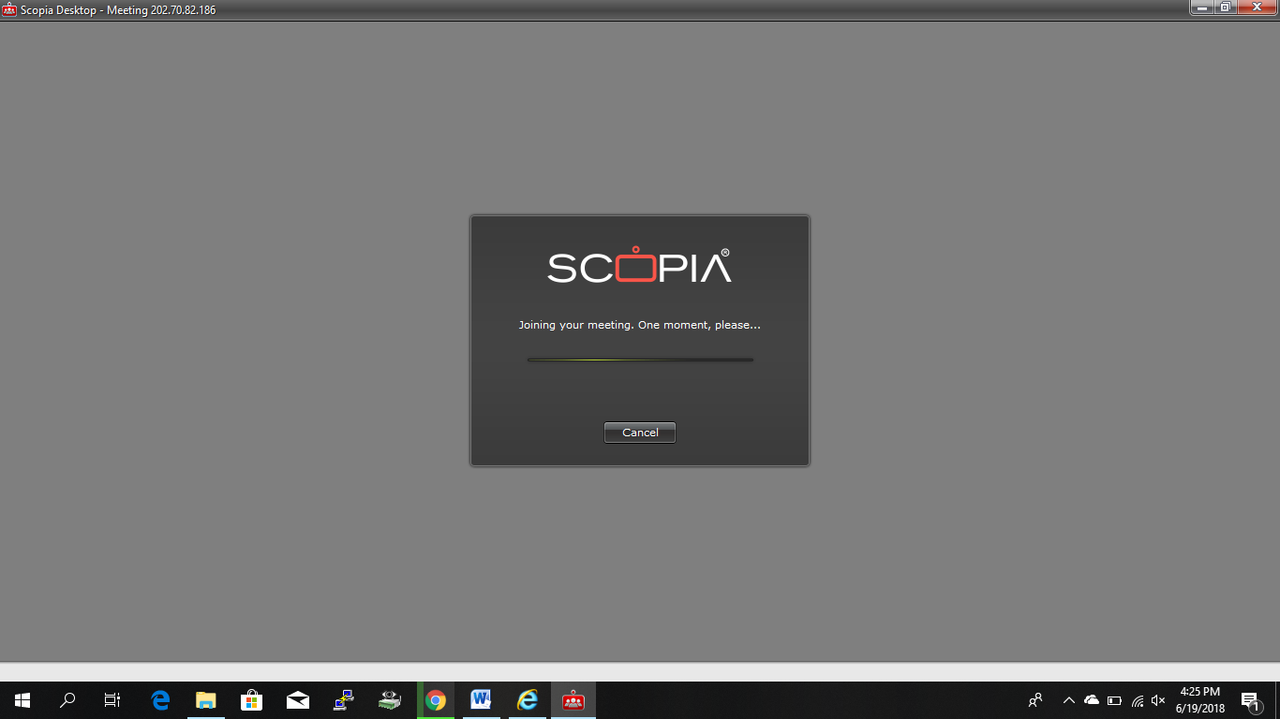

STEP6: The setup takes 10 seconds to complete and after the completion of initial setup the SCOPIA DESKTOP CLIENT window pop-ups connecting you to the destination video conferencing device as shown below
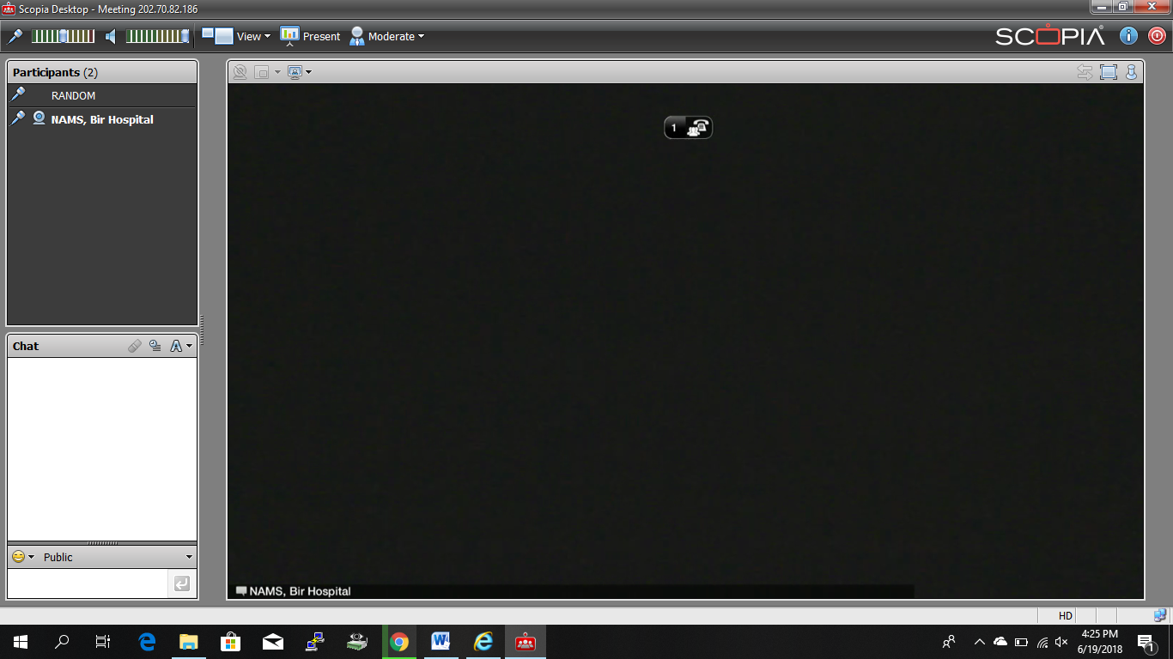

On MACBOOK:
STEP1 : Open “SAFARI” and enter the ip address in the address bar as shown below
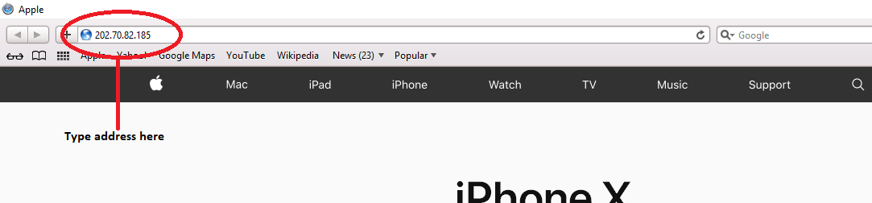

STEP2 : Press “ENTER” button on your keyboard and after entering the ip address in the address bar , you will be directed to the Scopia Desktop window where you will be asked for your name to be displayed throughout the video conferencing session as shown in the image below:
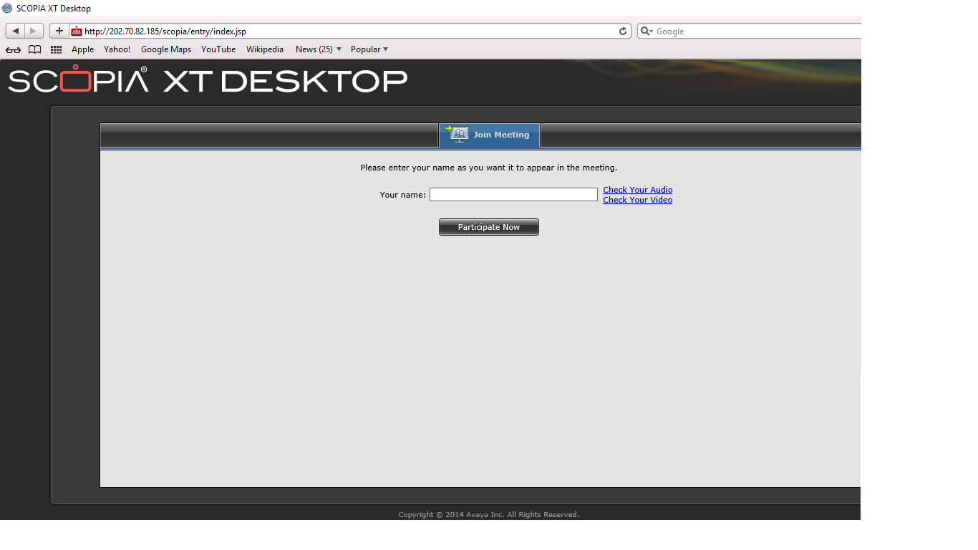

STEP3: Enter the name as preferred to be displayed during the meeting and click on “Participate Now” button which will direct you to the meeting room automatic initial setup as shown below:

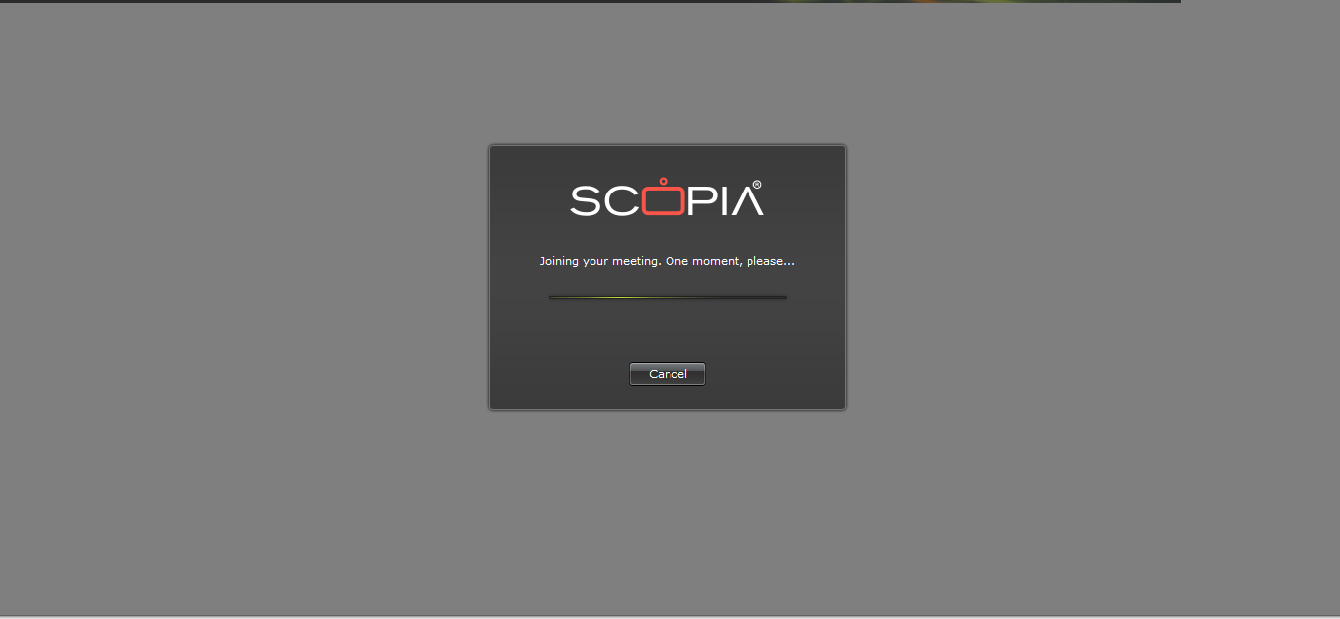

STEP4: The setup takes 10 seconds to complete and after the completion of initial setup the SCOPIA DESKTOP CLIENT window pop-ups connecting you to the destination video conferencing device as shown below
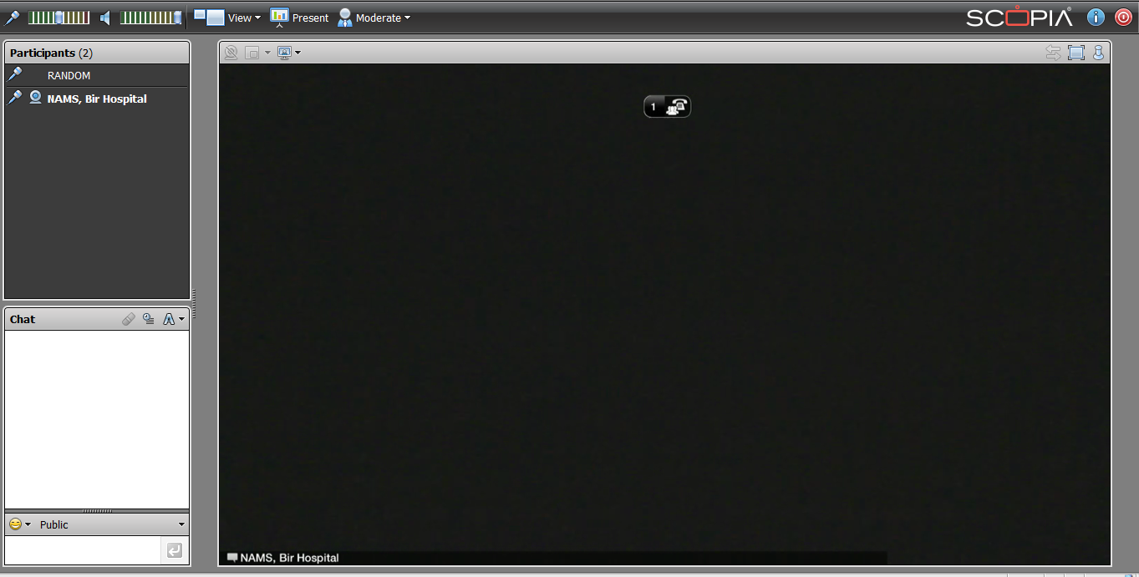

---- END OF DOCUMENT ----

