Flood relief campaign at Barju rural municipality, Amahibelha, Sunsari District
Date of the visit: 26th August 2017
Name of the place: Barju VDC, Amahibelha, Sunsari District
Purpose of the visit: Distribution of basic commodities including rice, pulses, salt, soya bean, potato, soap, bucket, jug, etc and construction of two simple pit latrines
ANMF team members/volunteers: Shaswat Acharya, Bikrant Rana, Surya Bikram Lamichhane
Name of the persons met and discussions done: Israel Ansari (local representative and a teacher at Madrasa i.e. Muslim school), Barju rural municipality health post incharge, ANM, local police officers
Discussions: The local representative and health post officials suggested that there is no need for the construction of simple pit latrines as the toilets were intact and most of the people there are using it but some of them still continue to open defecate, not because they lack toilet but because they are unaware of the harmful effects that could occur in future. Furthermore, they informed us that it would be fruitful if we could distribute additional nutrition supplies to postpartum mothers and pregnant women.
Activities done:
- ANMF team members and volunteers coordinated and assisted Sangsangai team members so as to distribute the 75 families of Barju VDC, who were highly affected by the flood
- As there was no need for the construction of simple pit latrines as suggested by a school teacher and health post officials, ANMF team members did not construct the latrines there and instead of that we distributed 17 additional nutritional package to pregnant women and postpartum mothers of Barju VDC and each package included a packet of Sarbottam Lito, 2 packets of Sarbottam Satu, 1 kg Chana, 2 Soaps and a towel
Recommendation:
- Apart from basic commodities the Barju VDC is in need of medical campaigns and the awareness programs
- Government officials (CDO, District coordination committee, rural municipality, municipality, Social Welfare Council, etc) should be updated about the conducted activities
- It would be good if we include government officials (government school teacher, secretary of rural municipality, police officer, etc) during the distribution program
- We should make sure to provide exact information to the village regarding the relief activity being conducted and to whom relief materials are being distributed (such as highly affected family or marginalized people or whole village)

Challenges:
- Effective assessment of the highly flood affected families and areas
- As every individual there was in need of the basic commodities and it was a challenge to distribute the basic commodities only to highly affected 75 families
- The additional nutritional package was distributed to 17 women who have visited Barju health post. As the source of information was the health post itself, there could be other women who have not visited the health post yet but are in need of additional nutritional supplies
- Time constraint
- Effective mobilization of the volunteers
- Proper coordination with the local people and the government
- Difficulty in procuring some of the food supplies as most of the organizations are purchasing the necessary supplies from the Biratnagar market

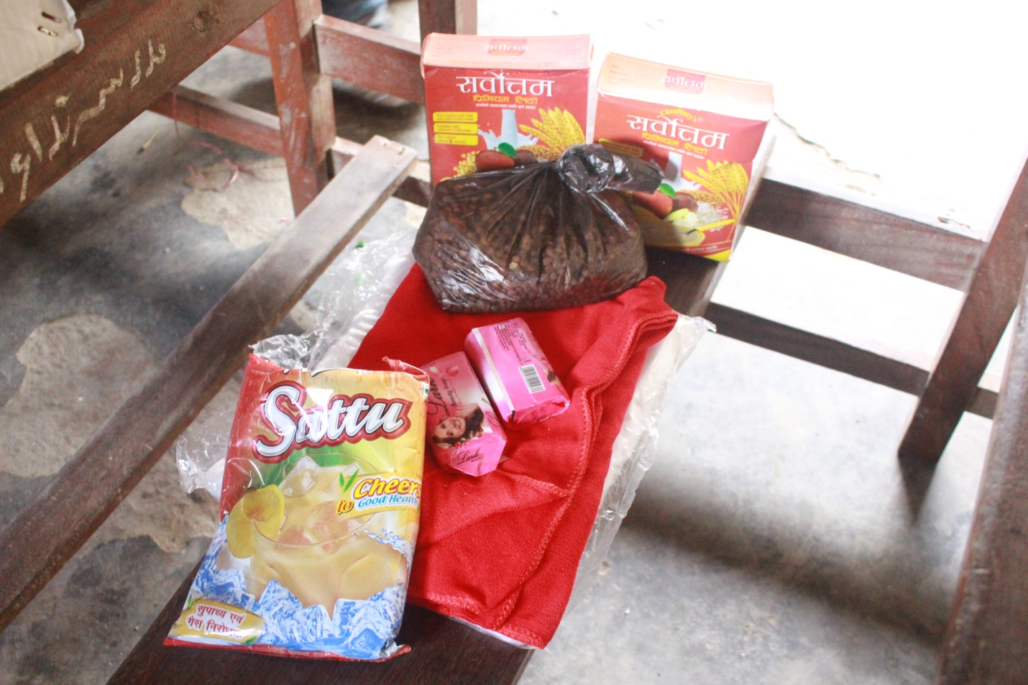
Fig: Constituents of each of the postpartum mother and pregnant women pack (Each pack was provided to 17 women at Barju rural municipality)

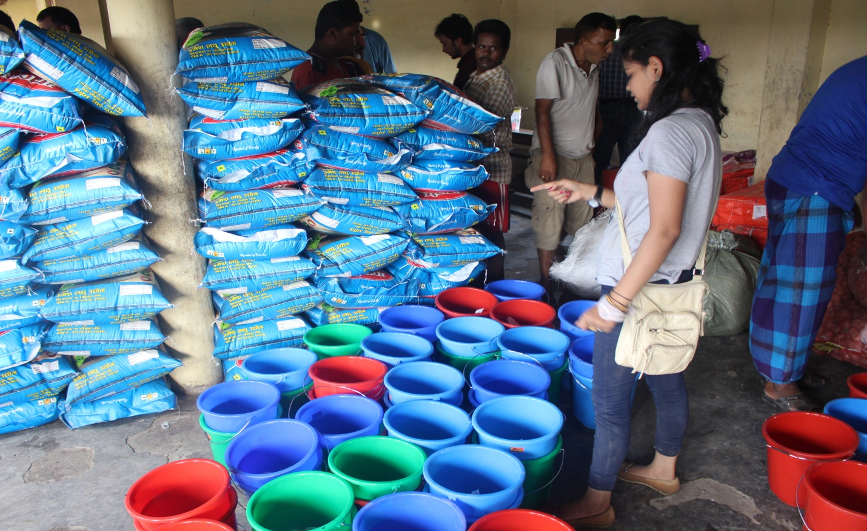
Fig: Supplies being organized
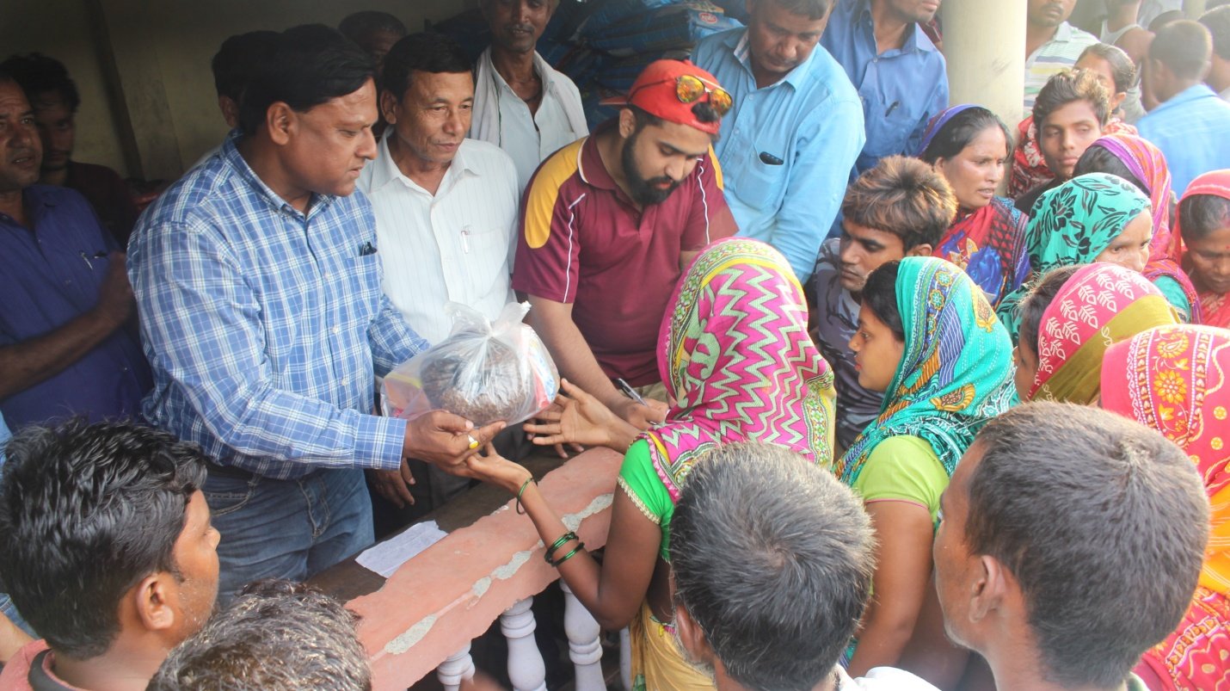
Fig: A pregnant and postpartum women pack being provided to a pregnant woman of Barju rural municipality by a local leader
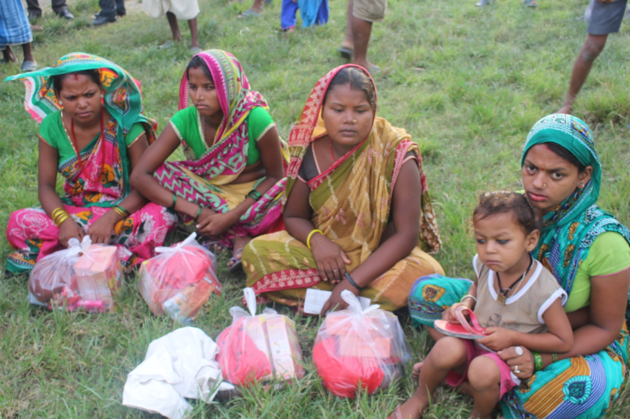
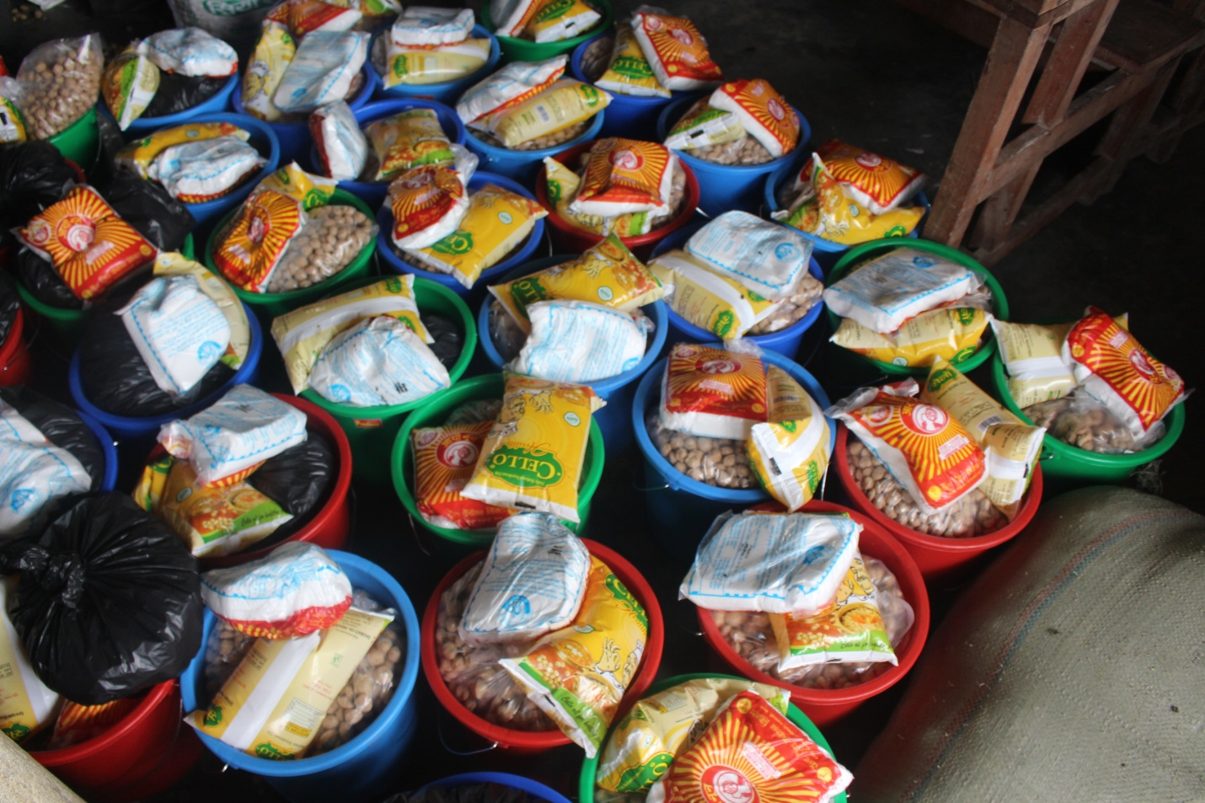
Please check the shared file via Google drive for video and further pictures

